Title | あなたの国の漫画
Unit/Activity No. | Manga and Anime/Activity 6
Topic | Manga, art technology
Function | Explain, narrate, summarize
Focus | Assess students’ achievement with a written quiz and group project.

I. BACKGROUND INFORMATION FOR TEACHERS

Teacher Instructions
- Before class prepare the handouts.
- Give Manga and Anime Unit Quiz to your students.
- Have the students form groups of three. Distribute Handout 2 and explain the group project.
- Have the students collect information and prepare their presentation. Collect each group’s vocabulary sheet and make copies for the rest of the students.
- Have each group give a presentation. Assess students’ performance using the scoring guide.

Materials
A couple of blank transparencies for each group

Answer Key to Student Activities
Handout 1
- 1) c. 2) d. 3) b. 4) a.
- 1) b. 2) a. 3) c. 4) d.

II. STUDENT ACTIVITY HANDOUTS

Handout 1

Manga and Anime Unit Quiz 名前: ＿＿＿＿＿＿＿＿＿＿＿＿
クラス：＿＿＿＿＿＿＿＿＿＿＿

1. We have learned some terminology of manga and anime. Connect the form in the left column with its description in the right column.

1) アニメ ＊ ＊ a. 漫画を描くのが仕事の人

2) コミック ＊ ＊ b. 漫画やアニメに出てくる人など

3) キャラクター ＊ ＊ c. テレビや映画の漫画

4) 漫画家 ＊ ＊ d. 漫画の本

2. We have also looked at some ancient art and early contemporary art. Read each of the descriptions of art below and match with an illustration.

Description | Illustration
- 現代の漫画の始まり。カメラのレンズで見たように、人や物の大きさや位置を変えて漫画を描いた。 | （ ）
- 江戸時代に描かれたスケッチ集。人や自然の動きをよく表している。 | （ ）
- 十二世紀に描かれた絵まき。人が火事から逃げているところ。 | （ ）
- 十二世紀に描かれた、漫画とアニメの原点。動物が子どものようにいきいきと描かれている。 | （ ）

a. | b.
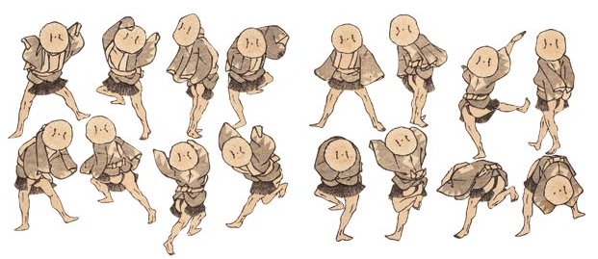 | 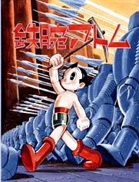
c. | d.
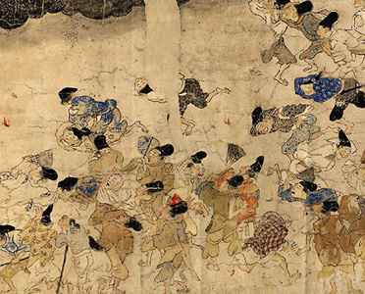 | 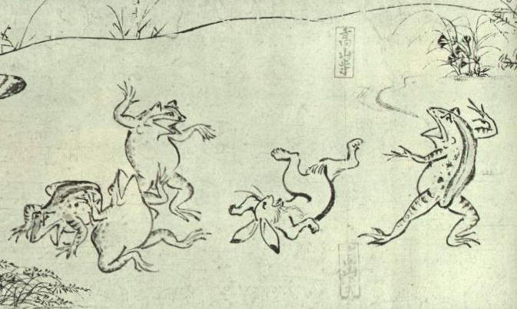

Handout 2

Group Project
In groups of three, conduct research about early manga or anime in your own country and present it to the class. In your presentation include:
- Title of the manga/anime
- Name of the author
- Year or century it was created
- Its genre
- Brief summary of the story

Preparation
Prepare a vocabulary sheet for your classmates and submit it to your teacher so that s/he can make copies.

Prepare visual aides to be used for your preparation.

Scoring Guide
 | Task completion | Comprehension | Use of presentation aids | Organization
Exceeds standards | 30: Information beyond requirement | 25: Comprehensible with ease, and rich grammar and vocabulary | 25:  Excellent visual and vocab. aides | N/A
Meets standards | 25:  Required information | 20:  Errors don’t interfere with comprehension, and adequate grammar and vocabulary | 20:  Sufficient visual and vocab. aides | 20:  Well organized
In progress | 20:  Some information missing | 15:  Some information is confusing or incomprehensible, and/or grammar and vocabulary need improvement | 15:  Insufficient visual and vocab. aides | 15: Somewhat organized
Far from meeting standards | 15:  Little information | 10:  A lot of information is confusing or incomprehensible | 10:  No visual or vocab. aid is used | 10:  Not organized and confusing
 |  |  | Total Score: | /100

IV. FOLLOW-UP ACTIVITIES

Students’ presentation materials can be compiled and uploaded to a website. If your school has a sister school in Japan, you can ask the students to look at the website and give your students comments.

