Title | ¿En qué trabajamos?
Unit/Activity No. | Immigration Unit 1/Activity 3
Geographic Topic | Economic activities and patterns
Language Topic | Jobs, places
Language Function | Describe, compare
Language Standard | 1.3  3.1
Geography Standard | 3, 9

I. BACKGROUND INFORMATION FOR TEACHERS

Teacher Instructions
Step 1. Before class prepare a handout and a transparency.
Step 2. Place students into groups of three and distribute the activity and two blank sheets of paper to each group.
Step 3. Complete Paso 1.
Step 4. Have the students draw the two counties on the black sheets of paper and complete Paso 2.
Step 5. Present to class.

Materials
Statistical information by county that indicates: socioeconomic groups and economic activity (agricultural, industrial, commercial, etc). See maps and tables in ATLAS OF OREGON (University of Oregon Press), pp. 64, 67, 72-77.

Maps of each county in Oregon or of a certain region of Oregon

Markers, magazine clippings/graphics representing different products, industries, etc.

Suggestions
You can do this activity using regions of the state, rather than counties (e.g. Willamette Valley, costal Oregon, High Desert, Columbia Valley, etc.)

Students may need some examples in Paso 2 to help them represent the data graphically. For example, for economic sectors, they could draw small pictures or use magazine cutouts of computers, trees in a forest, farm products or equipment, etc. See also Immigration Unit 1/Activity 2, Los mapas cloropleth.

The following list is long; review or preteach only the vocabulary for jobs, industries, or sectors that are appropriate to the regions being discussed. Be sure to provide any additional items that are of interest to students. To integrate this vocabulary, have students do circumlocution activities, e.g. students write definitions of what each profession does, read their definitions to a partner, who tries to guess the profession.

MODELO
S1: Esta persona trabaja en un hospital y cuida a los pacientes.
S2: ¿Es enfermera?
S1: No, esta persona también hace operaciones.
S2. Es médico.

Las profesiones:

el (la) abogado(a) | lawyer
el actor | actor
la actriz | actress
el (la) agente de viajes | travel agent
el (la) agricultor(a) | famer
el (la) arquitecto(a) | architect
el (la) artista | artist
el (la) atleta | athlete
el (la) autor(a) | author
el (la) barbero(a) | barber
el (la) bombero(a) | firefighter
el (la) cajero(a) | cashier
el (la) camarero(a) | waiter
el (la) cantante | singer
el (la) científico(a) | scientist
el (la) cocinero(a) | chef, cook
el (la) dependiente | store clerk
el (la) doctor(a) | doctor
el (la) enfermero(a) | nurse
el (la) escritor(a) | writer
el (la) farmacéutico(a) | pharmacist
el (la) fotógrafo | photographer
el (la) ingeniero(a) | ingineer
el (la) intérprete | interpreter
el (la) jardinero(a) | gardener
el (la) locutor(a) | newscaster
el (la) maestro(a) | teacher
el (la) mecánico(a) | mechanic
el (la) médico(a) | doctor
el (la) músico(a) | musician
el (la) panadero(a) | baker
el (la) peluquero(a) | hair dresser
el (la) periodista | journalist
el (la) piloto(a) | pilot
el (la) pintor(a) | painter
el (la) plomero(a) | plummer
el (la) político(a) | politician
el (la) programador(a) | programmer
el (la) reportero(a) | reporter
el (la) secretario(a) | secretary
el (la) traductor(a) | translator
el (la) vendedor(a) | salesperson
la clase media | middle class
la clase obrera | working class
la clase alta | upper class
la clase baja | lower class
rico /a | rich
la riqueza | wealth
Pobre | poor
la pobreza | poverty
la mayoría | majority
la minoría | minority
la actividad económica | economic activity
la agricultura | agriculture, farming
la selvicultura | forestry
el comercio | business
la industria | industry
el sector tecnológico | high tech sector
La pesca | fishing
El turismo | tourism
El sistema educativo | Education system

Para comparar
más que | more than
menos que | less than
más/menos de (+ number) | more/less than (+ number)

II. STUDENT ACTIVITY HANDOUTS

Handout 1
Paso 1. Working in a group of three students, pick two counties from the map that have variation in socioeconomic level or economic activity. Write sentences in Spanish that compare the two counties.

MODELOS
En el condado de Washington hay más trabajos en el sector tecnológico que en todo el sur del estado.
La mayoría de los trabajos en el suroeste del estado están en el sector de selvicultura.

Paso 2. Use a blank map of the two counties to indicate visually the difference in the statistics you described in Paso 1.

Paso 3. Present your group’s information to the class. Include a description of the geographical location and place your graphic in its correct position relative to the other groups’ maps on a bulletin board or wall.

III. VISUAL AID FOR TEACHERS

Transparency 1
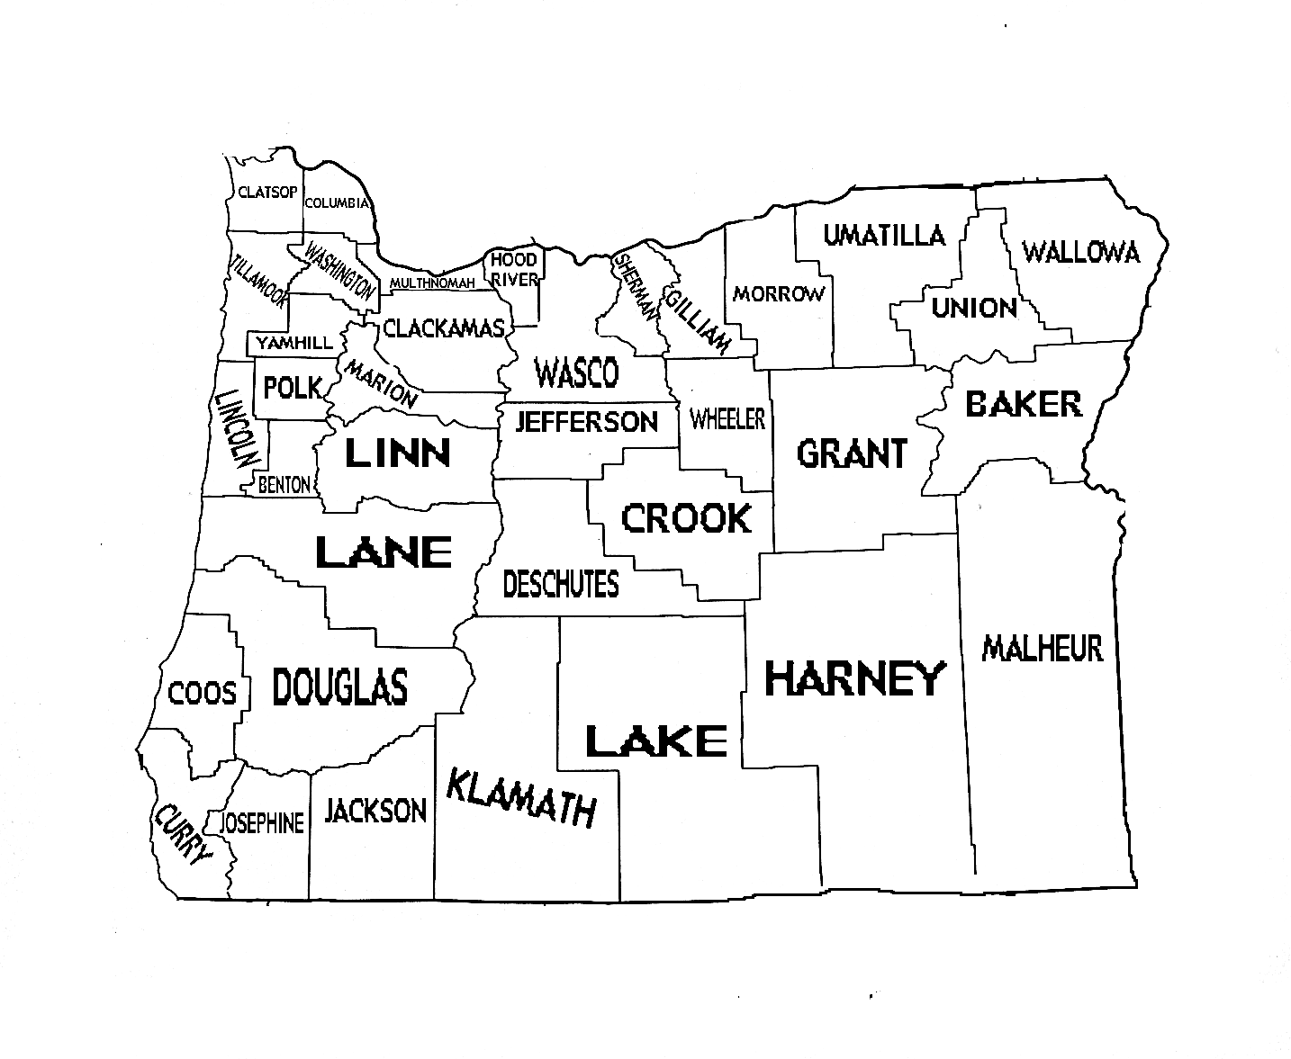
Transparency 2
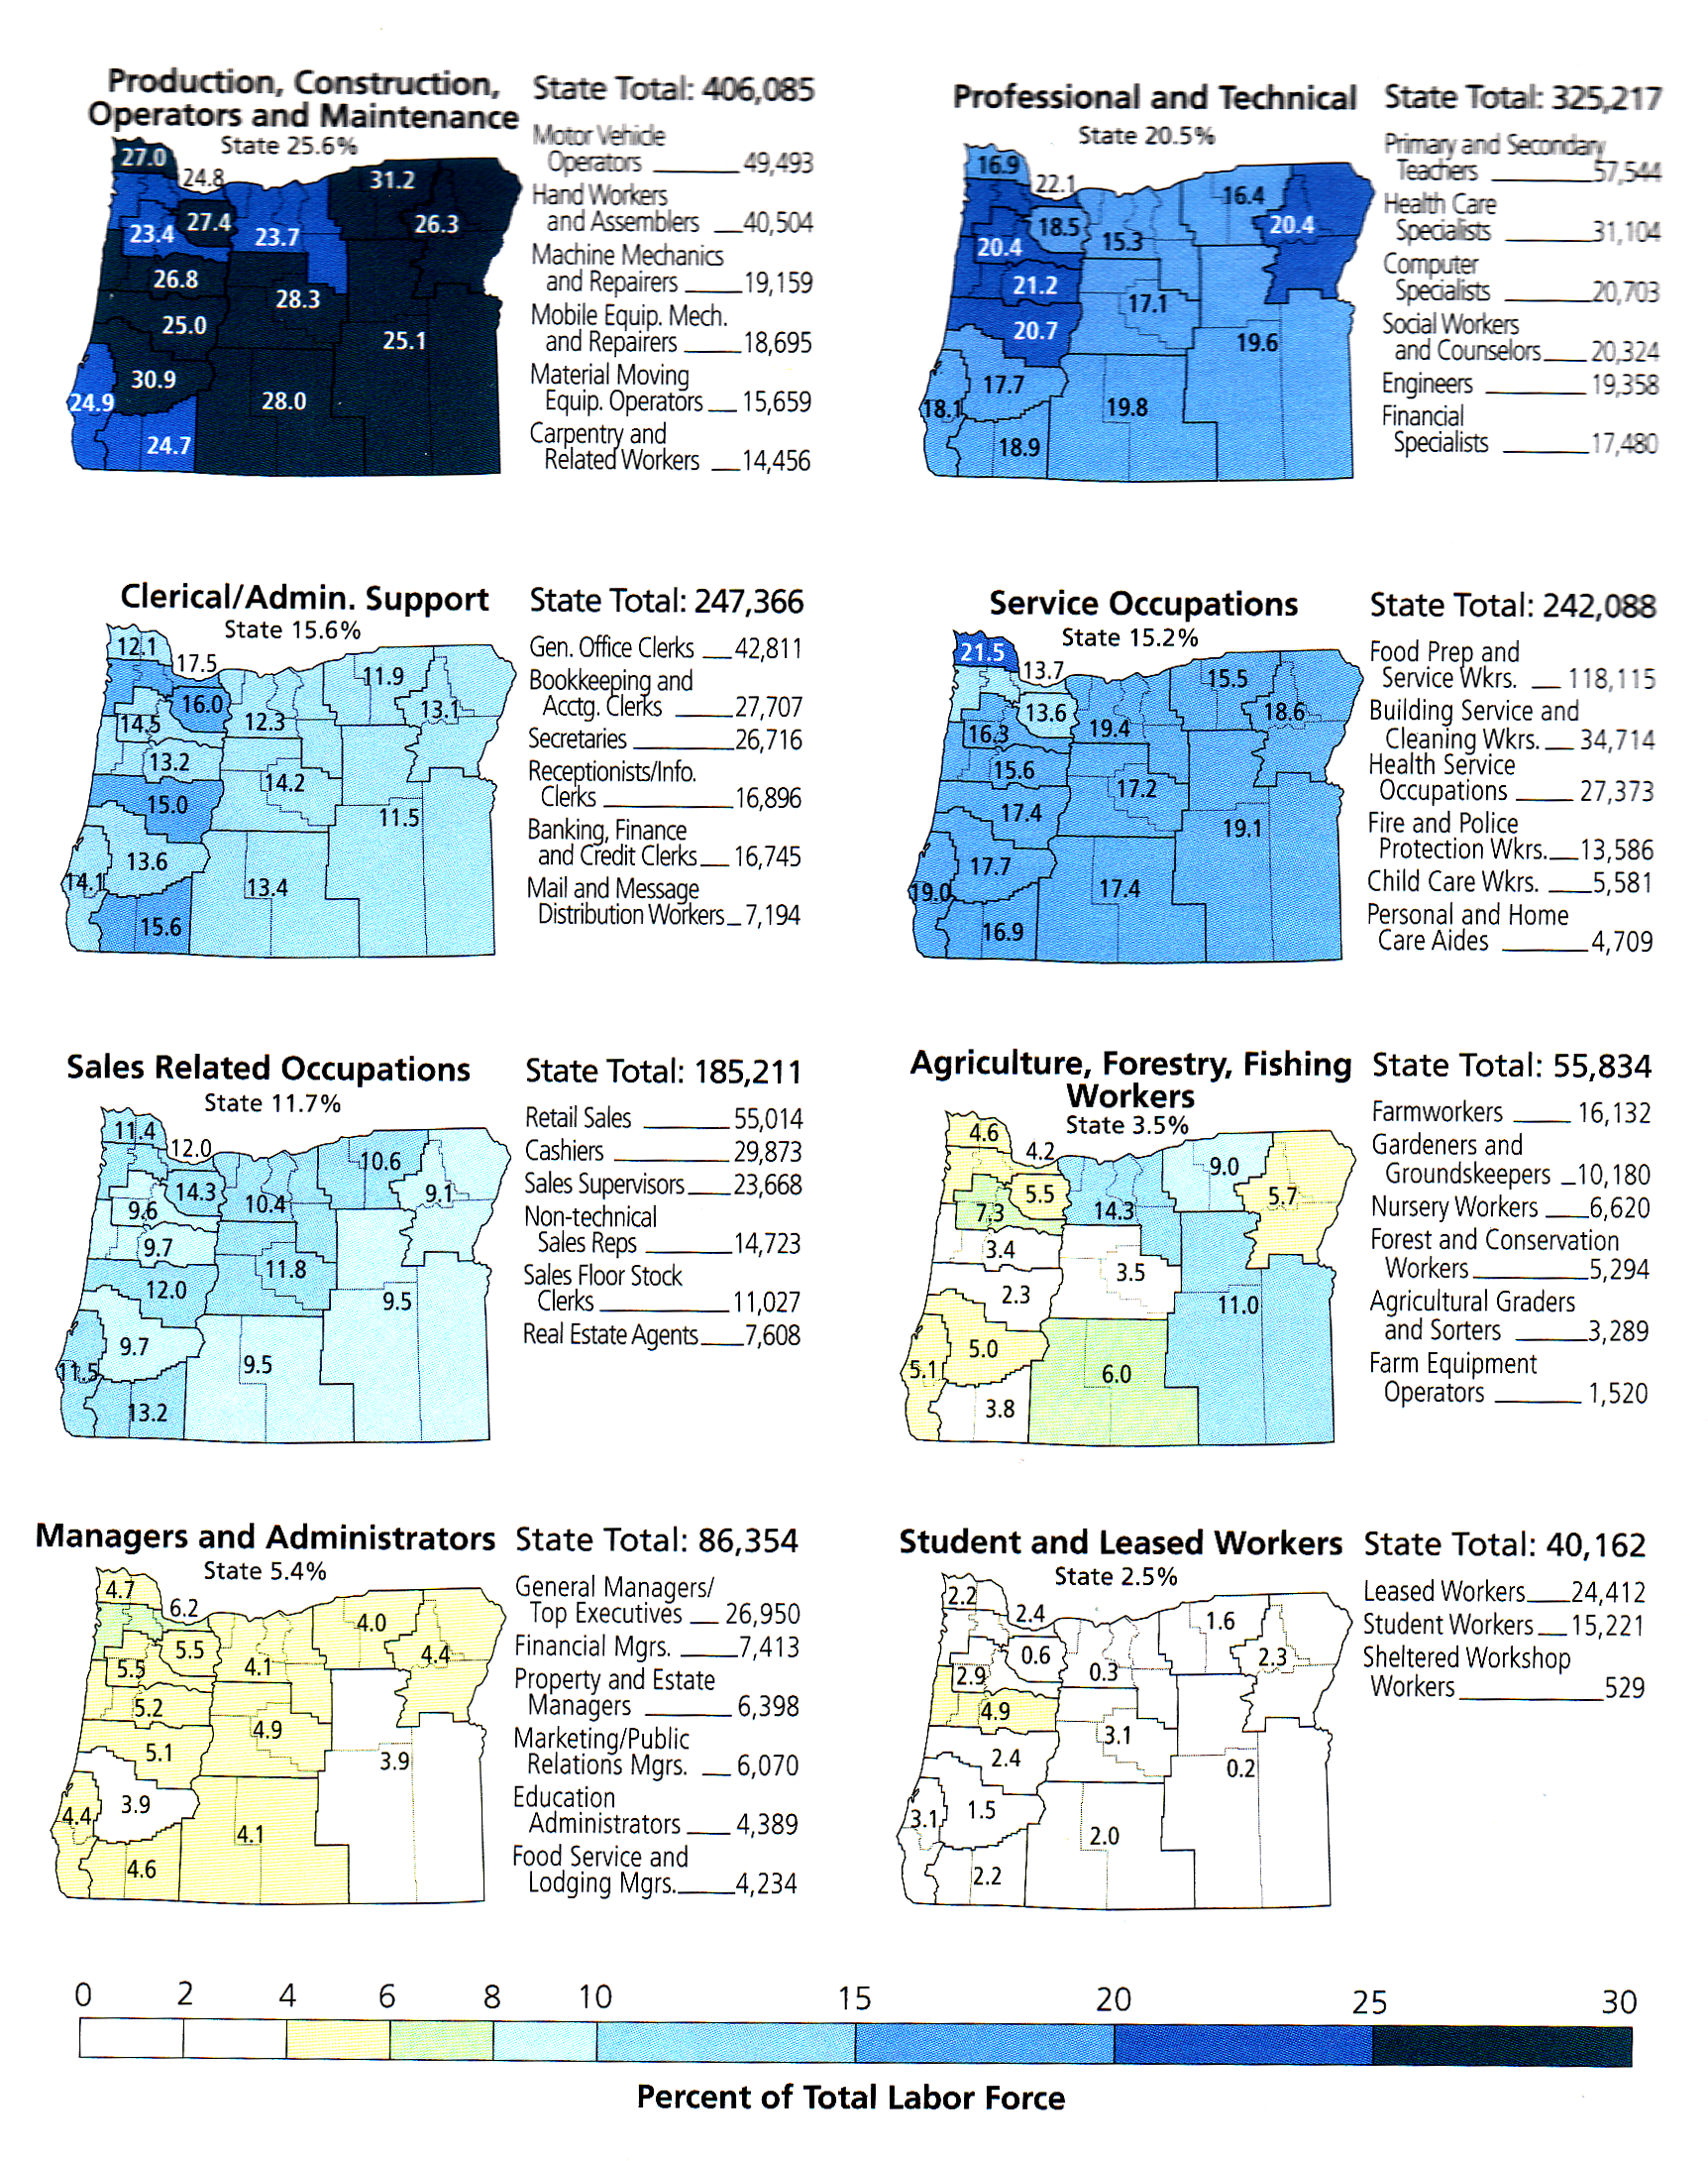
Transparency 3

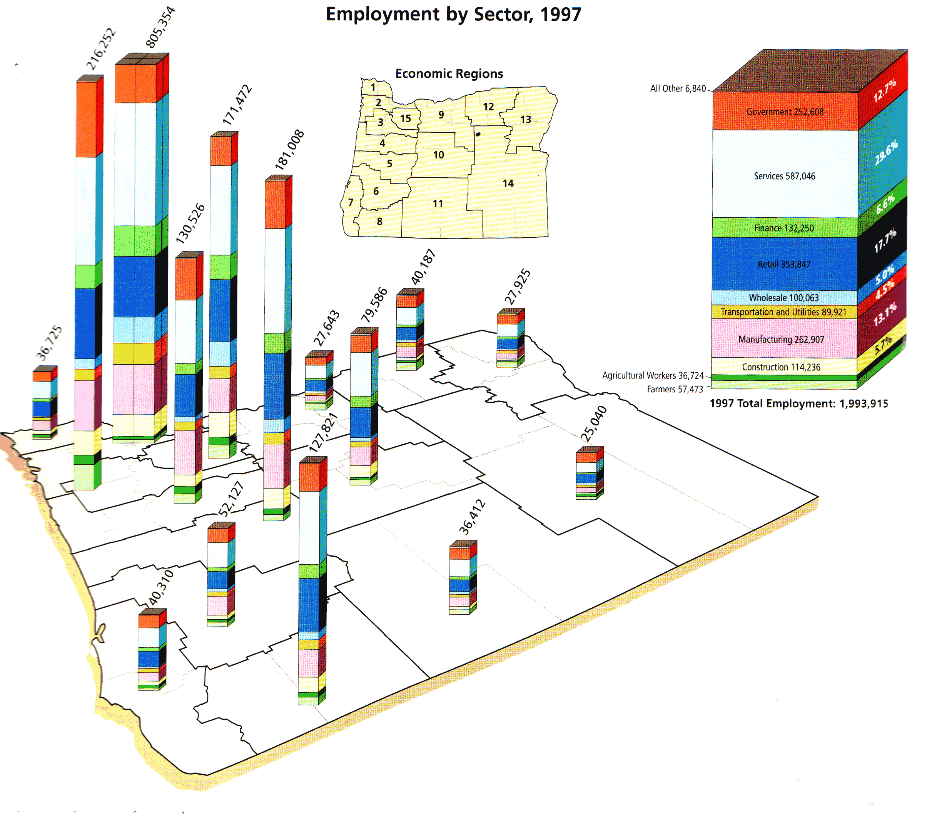

IV. FOLLOW-UP ACTIVITIES

1. If you have done the activity ¿Quién vive en esta región? (Activity 4), have students combine the data from the two maps. Then they can try to make more complicated comparisons in Spanish, relating ethnic composition and economic activity.

MODELO
En el valle del Willlamette, la mayoría de los inmigrantes mexicanos trabajan en la agricultura, no en la selvicultura.

2. Have students describe in Spanish the county in which their school is located (Lane, for example). Report the Lane County information to the class on a transparency. Groups of three or four students then come up with specific examples from their personal experience that illustrate the statistics they have just learned about their county. For example, local industries that make certain products (agricultural, industrial, or commercial), visible examples of the presence of certain ethnic populations (markets, restaurants, cultural events), etc.

